MTH 200 | Optimization Mins&Maxes

Directions: Solve all problems on a separate sheet(s) of paper. Place your name on the pages you submit. You must show all of your work to receive full credit on problems. You must write complete sentences when asked to show/prove something or provide an explanation/justification. You are encouraged to work with others, consult sources, use calculators, etc. However, only submit solutions that you fully understand. Do not submit solutions which are copied from a friend or another source.

Challenge Questions

Optimization maxes/mins

- If a tank holds
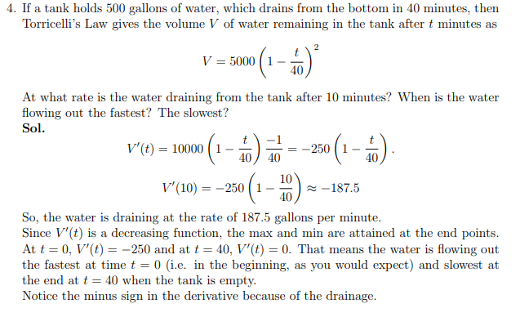

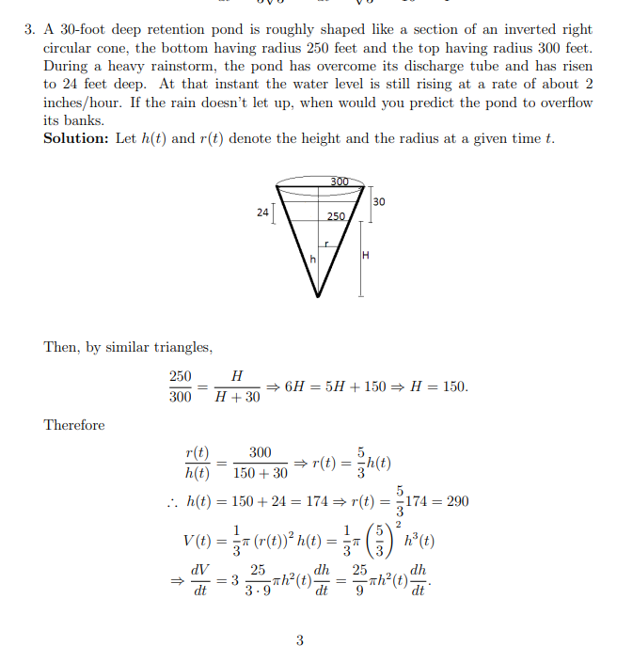
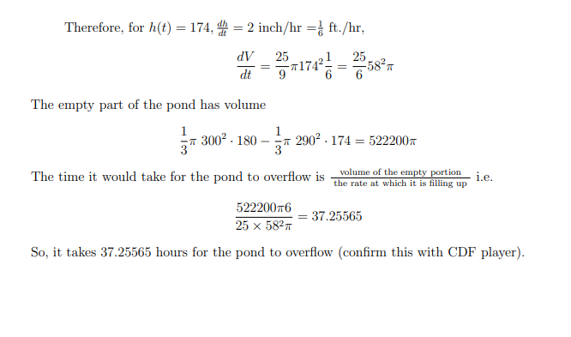
- A farmer is going to use fence to make a pen shaped like cutting a circle in half and inserting a rectangle.
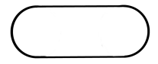

If the pen is to have an area of , how should he make the pen to minimize the amount of fence needed? Find all dimensions of the pen and sketch a picture of it.
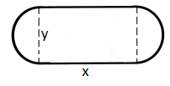
We begin by labeling the diagram as follows.

We can therefore calculate the total amount of fencing used as
We know that the area of the pen is given by . Since the pen needs to have an area of this means that .
With this information we can state that

We then calculate

We see that
when
is undefined when

We put these values on a number line to determine where T has a minimum.

$$-$$
$$+$$
$$MIN$$
Note that we aren’t consider with values below 0 since these are not possible radius lengths.

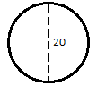
So, we have that if then the total amount of fencing used would minimized.
This implies that which means that the pen would ultimately be in the shape of a circle.

- Consider the function where a and b are real numbers.
- Find values of a and b such that has a local extreme value of 1 at .

In order to see where has local mins and maxes we find .
If there is to be a local max at then must correspond to a critical point of f and therefore make either equal to 0 or undefined. Clearly does not make undefined so we need to find values of a and b such that .

So, we must have:

Since we want a local extreme value of 1 this means that we also need .
So, we also must have:

In order for both of these things to be true we must have values of a and b that satisfy the system
We solve this system and find that

This means that and

- Determine whether the extreme value is a local minimum or maximum.

We see that f has critical values of . We put these on a number line and find…
$$-$$
$$+$$
$$+$$
$$-$$
$$MAX$$

This shows us that is a local maximum of the function .

- Consider the function .
- Determine the exact value of x at which increases most rapidly. Hint: Something is being optimized here. What function are we trying to maximize?

If we want to find when increases most rapidly we are looking for the time when has a tangent line with the largest slope. This means that we actually need to maximize .

We compute that .
To maximize this function we need to find its derivative and then progress through the normal techniques of finding maximums.

We compute
.
when
is never undefined.

We put these values on a number line and check for where there are maxes and mins.
$$+$$
$$-$$
$$+$$
$$MIN$$
$$MAX$$

It appears that there is local maximum at but we cannot be sure that values after end producing even larger values.

We check the to see the end behavior of the graph.
This is interesting because it means that the function is increasing after up until the y-value of 0. Note that the function cannot go past this y-value otherwise it would have to decrease, and we note that the function only increases past .

This means that there must be an absolute maximum value at .

- Reflect on your work in part (a). What does your work here imply about the significance of inflection points?

We can see that there is an inflection point on at and this corresponds to the point at which increases most rapidly. So, in general inflection points are points on function where that function can potentially be increasing or decreasing most rapidly.

- Two poles, one 6 meters tall and one 15 meters tall, are 20 meters apart. A length of wire is attached to the top of each pole, and it is staked to the ground somewhere between the two poles. Where should the wire be staked so that the minimum amount of wire is used?

We draw the following diagram of the scenario.
The length of wire connected to the left pole is given by and the length of wire connect to the right pole is given by .
Therefore, the total length of all the wire is given by .
This is already a function of one variable and so we take its derivative in order to find if it has a minimum.

We calculate:
We see that is never undefined.
when . This occurs when

